A000-Mex-Olmec-Jaguar Shaman-1100 BCE

MASTER?

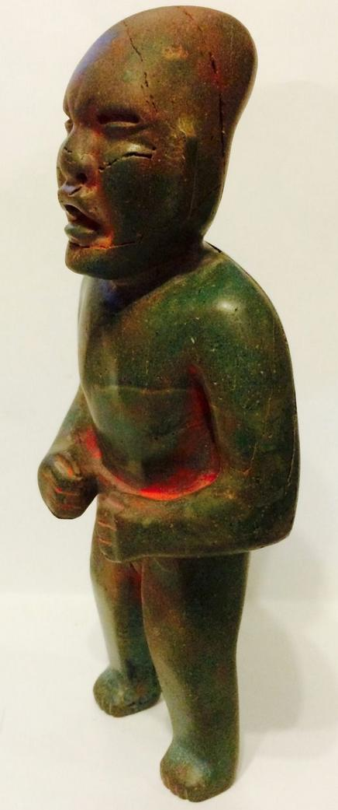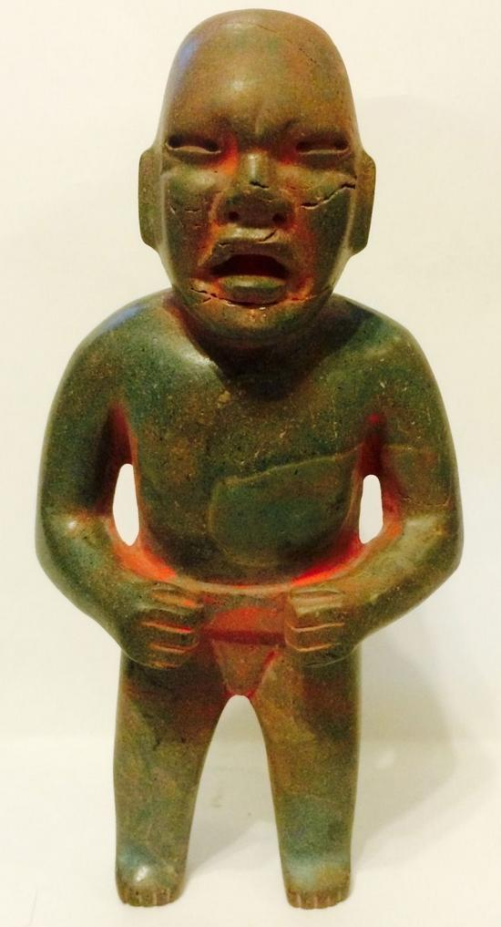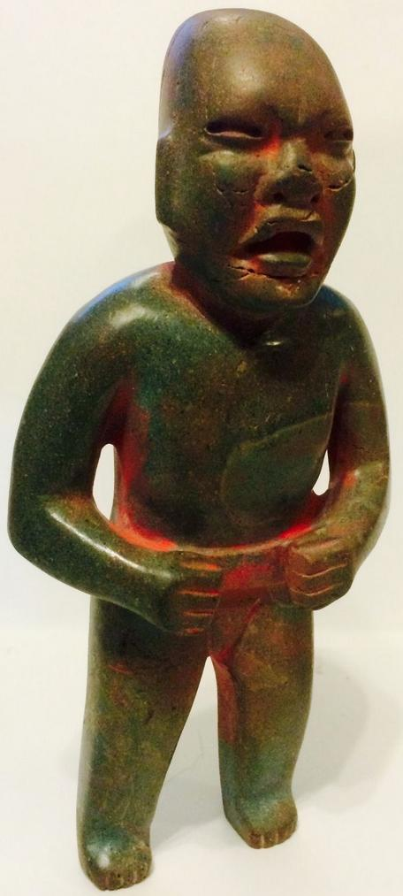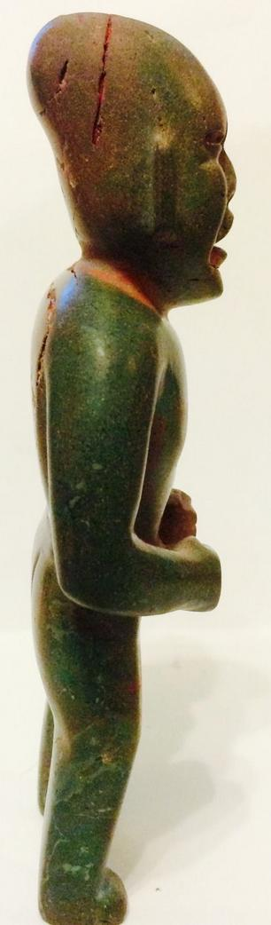

Pre-Columbian Olmec standing figure on jade found in Campeche in the early 60's and imported to the US. It depicts a jaguar shaman with an elongated skull on which traces of cinnabar have been applied in ceremonial activities. Erosion of the jade due to weathering is throughout the piece. It measures: height 6", depth 1 1/2", width 3".

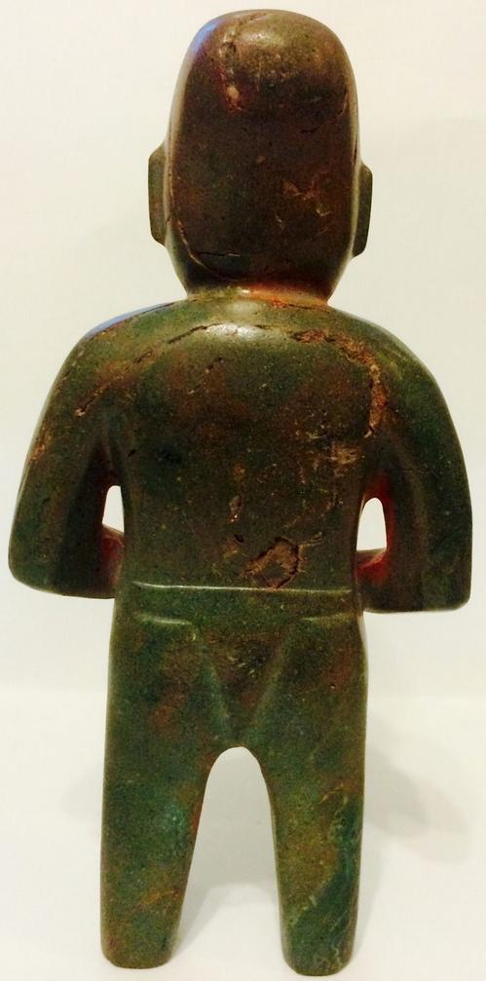

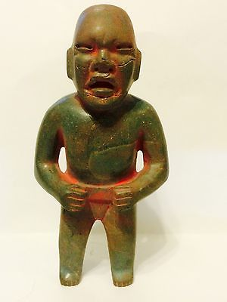

#### [Pre columbian Transformation Olmec green stone standing figure.](http://www.ebay.com/itm/271983678640)